**诚信应考,考试作弊将带来严重后果！**

姓名 学号 学院 专业 座位号

( 密 封 线 内 不 答 题 )

……………………………………………………密………………………………………………封………………………………………线……………………………………线………………………………………

_____________ ________

…

**华南理工大学期末考试**

**《软件体系结构》试卷(B)**

**注意事项：1. 考前请将密封线内填写清楚；**

**2. 所有答案请书写在试卷上；**

**3．考试形式：闭卷；**

**4. 本试卷共 三 大题，满分100分， 考试时间120分钟**。

|  |  |  |  |  |
| --- | --- | --- | --- | --- |
| **题 号** | **一** | **二** | **三** | **总分** |
| **得 分** |  |  |  |  |
| **评卷人** |  |  |  |  |

1. 选择题(共30分，每题3分，共10条题)

|  |  |  |  |  |  |  |  |  |  |  |  |
| --- | --- | --- | --- | --- | --- | --- | --- | --- | --- | --- | --- |
| 题号 | 1 | 2 | 3 | 4 | 5 | 6 | 7 | 8 | 9 | 10 | 总分 |
| 答案 | A | A | C | B | A | C | D | H | C | D |  |

* 1. The Model-View-Controller structure is a kind of ( ) ?

1. Module structures
2. Component and Connector Structures
3. Allocation Structures
4. Non of the above
   1. Which of the following tactics is possible for preventing Faults EXCEPT ?
5. Heartbeat
6. Removal from Service
7. Transactions
8. Predictive Model
   1. Which of the following statements is true for the broker pattern EXCEPT?
9. Broker is a crucial component of service-oriented architecture in the form of ESB.
10. A client requesting some information from a server does not need to know the location or APIs of the server.
11. The direct communication between the client and the server is desirable.
12. The broker can be a single point of failure.
    1. ( ) guarantees that the sender of a message cannot later deny having sent the message,and that the recipient cannot deny having received the message..
13. Authentication
14. Nonrepudiation
15. Authorization
16. Confidentiality
    1. The main benefit and the major driver of Publish-Subscribe Architecture pattern is ( )
17. Support the ability to transmit messages among the producer and the consumer.
18. Support the ability to share state for complex interactions.
19. Performance
20. scalability
    1. When a company designs the architecture for the embed software system of the garage door opener, One of the scenario is that “The garage door opener should be accessible for remote diagnosis”. The scenario is relative to the quality attribute of ( ).

A. Usability B. Security C. Testability D. Modifiability

* 1. According to the Up-front design work and Rework synthesized model of Boehm and Turner, for the 100 KSLOC project, the sweet spot is at around ( ) percent of the project schedule.

1. 50%
2. 40%
3. 60%
4. 20%
   1. Maintain Audit Trail is an architecture tactic for
5. Testability
6. Availability
7. Performance
8. Security

* 1. Which of the following statements is NOT true for the the Utility Tree?

1. Utility Tree is a tool to identify and prioritize the ASRs.
2. ASRs that rate a (H, H) rating are the ones that deserve more attention than the ASRs that rate a (L, L) rating.
3. One ASR expresses one quality attribute and so should not appear in more than one place in the tree.
4. ASRs are usually expressed as quality attribute scenarios.
   1. Which of the following statements is NOT true for the the SOA pattern?
5. The basic types of connectors used in SOA are SOAP and REST.
6. ESB is a component of the SOA, in which service invocation can be mediated..
7. Service providers may also be service consumers.
8. Service consumers are connected to service providers without any intermediary components.
9. 简答题(共30分，每题6分，共5条题)

|  |  |  |  |  |  |  |
| --- | --- | --- | --- | --- | --- | --- |
| 题号 | 1 | 2 | 3 | 4 | 5 | 总分 |
| 得分 |  |  |  |  |  |  |

1. Please list the 5 steps of the ADD and describe the outputs of ADD. （Score 6）

**1. Choose an element of the system to design**

**2.Identify the ASRs for the chosen element**

**3. Generate a design solution for the chosen element**

**4. Inventory remaining requirements and select the input for the next iteration**

**5. Repeat steps 1-4 until all the ASRs have been satisfied**

**Output：**

**A set of sketches of architectural views, not a full-blown detailed architecture**

***（一个点一分）***

1. Please describe the components, connectors and constrains of the Map-Reduce pattern. （Score 6）

Map is a function with multiple instances deployed across multiple processors that perform the extract and transform portion of extract-transform-load.

Reduce is a function that may be deployed as a single instance or as multiple instances across multiple processors to perform the load portion of extract-transform-load.

The data to be analyzed must be exist as a set of files.

The map functions are stateless and do not communicate with each other.

The only communication between the map instances and the the reduce instances is the data emitted from the map instances as <key,value>

1. Most peer-to-peer architecture employs late binding of the topology.What quality attributes does this promote or inhibit?（Score 6）

This will promote flexibility, efficiency, interoperability, portability, maintainability, reusability but inhibit testability, reliability, availability

1. Discuss the choice of programming language (an example of choice of technology) and its relation to the design decisions in one of the other six categories? For instance, how can certain programming languages enable or inhibit the choice of particular coordination models? （Score 6）

设计决策中的开发技术选项与架构总体的设计关系应该是相辅相成的，其开发技术选项是软件架构设计的一部分，但是选择的开发技术由于有不同的特性也会发过来影响总体的软件架构。其他六种设计决策为：Allocation of responsibilities（责任分配）、Coordination model（协调模型）、Data model（数据模型）、Management of resources（资源管理）、Mapping among architectural elements（架构元素之间的映射）、Binding time decisions（结合时间的决定），

1. Choice of technology（技术的选择）是最后一个策略。在能达到剩下的六个设计决定提出的目标的情况下选择可行的技术，并且选择技术后反过来又会对这六个设计决定有一定的限制。例如：Binding time decisions与choice of technology 有很大的关联，你可以为智能手机建立一个应用程序商店，可以自动下载应用程序的相应版本。Choice of technology会对其他六种策略有一定的影响，如所需的协调模型或受约束的资源管理，技术选择对于协调模型的影响是很大的，例如C++编程语言与JAVA编程语言的选择上，C++编程语言频繁使用指针，但JAVA语言是纯面向对象语言，若选择C++语言，则要在协调模型中考虑到指针所可能造成的内存泄露的问题。故在choice of technology时不仅是考虑该技术能否实现软件功能的问题，更要从全面的架构设计方面去考虑，并且结合其他六种策略进行考虑选择。
2. Explain the Map-Reduce pattern with the view of component-and-connector. （Score 6）

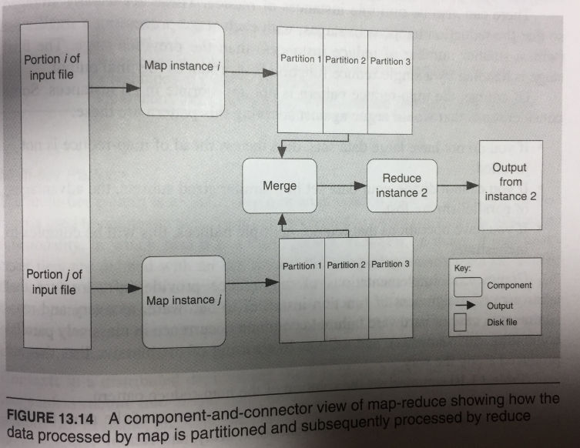

1. 综合题(共40分，每题10分，共4条小题)

|  |  |  |  |  |  |
| --- | --- | --- | --- | --- | --- |
| 题号 | 1 | 2 | 3 | 4 | 总分 |
| 得分 |  |  |  |  |  |

Suppose there are some interactive scenarios for a distributive project management team, which includes the following users, devices and tasks:

1. Project members communicate and collaborate with the interactive devices, such as PC, mobile phone;
2. Users login the targeted system with their familiar styles;
3. As a project manager, the user can create the team, create the project and invite the project members with some effective ways, such as eMail, anytime and anywhere.
4. One project manager can create more than one team, and one team can own many projects and one project can own many project members.
5. Project manager can start and manage the communication with members anytime and anywhere.
6. Project manager can create the task list and when creating the task, he or she can assign the task to some member with a deadline.
7. Project manager can know about the dynamic state of the project.
8. Project members can communicate with each other by some agile styles, such as memo or note.
9. Project members communicate with each other in the way of task, memo, discussion, week report, and reminding.
10. Project members accept the assignment and give feedback for the assignment.
11. Project members can know about the state of his or her participation of the project by checking up the finished or unfinished assignment.
12. Each project member can equally know about the latest status of the project.
13. All of the messages, which have relation to the members, would be informed to the members as soon as possible.

As a software architect of the project, in order to meet the demands of the interactive scenarios stated above, you are asked to present the architectural design for the expected system following the steps of the ADD (Attribute-Driven Design) method.

* 1. Please present the tabular form of Utility Tree with quality attributes,attributes refinement. (Score 10)

Availability

Security

Performance

* 1. Please make architectural decisions by choosing 2 architectural patterns to achieve the ASRs. (Score 10)

C/S+B/S

MVC

* 1. Present a component and connector architectural view of the expected system with the UML notations. (Score 10)
  2. .Please explain the constrains and weaknesses of the selected architectural patterns. (Score 10)